SEQUENCE DIAGRAM 1:

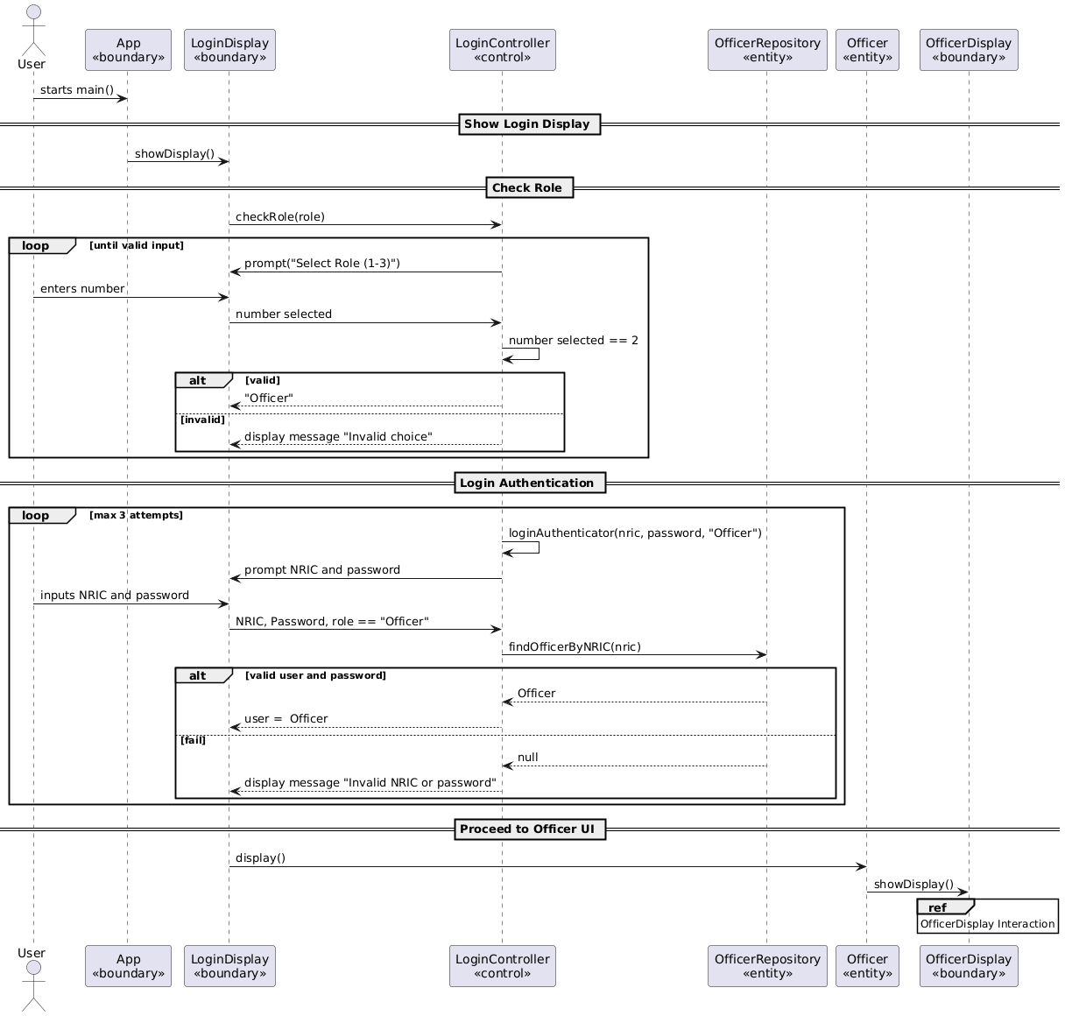

SEQUENCE DIAGRAM 2:

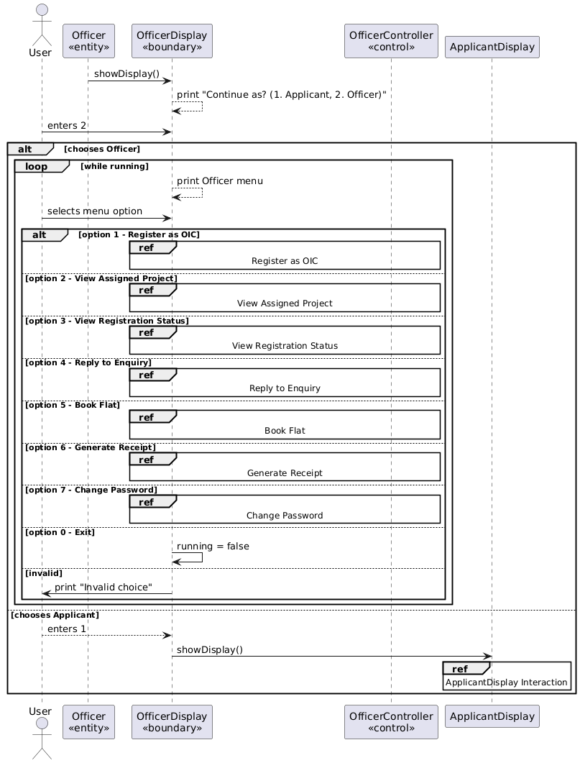

SEQUENCE DIAGRAM 3:

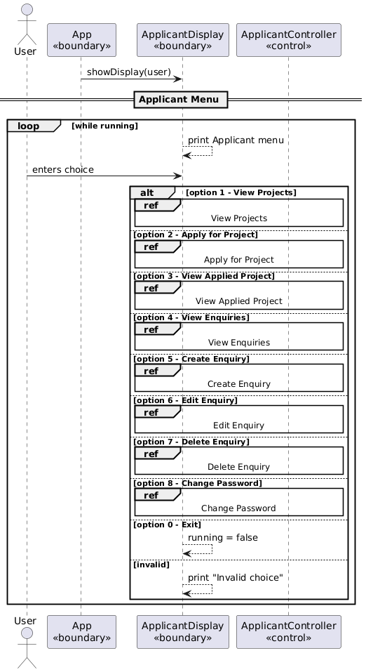

SEQUENCE DIAGRAM 4:

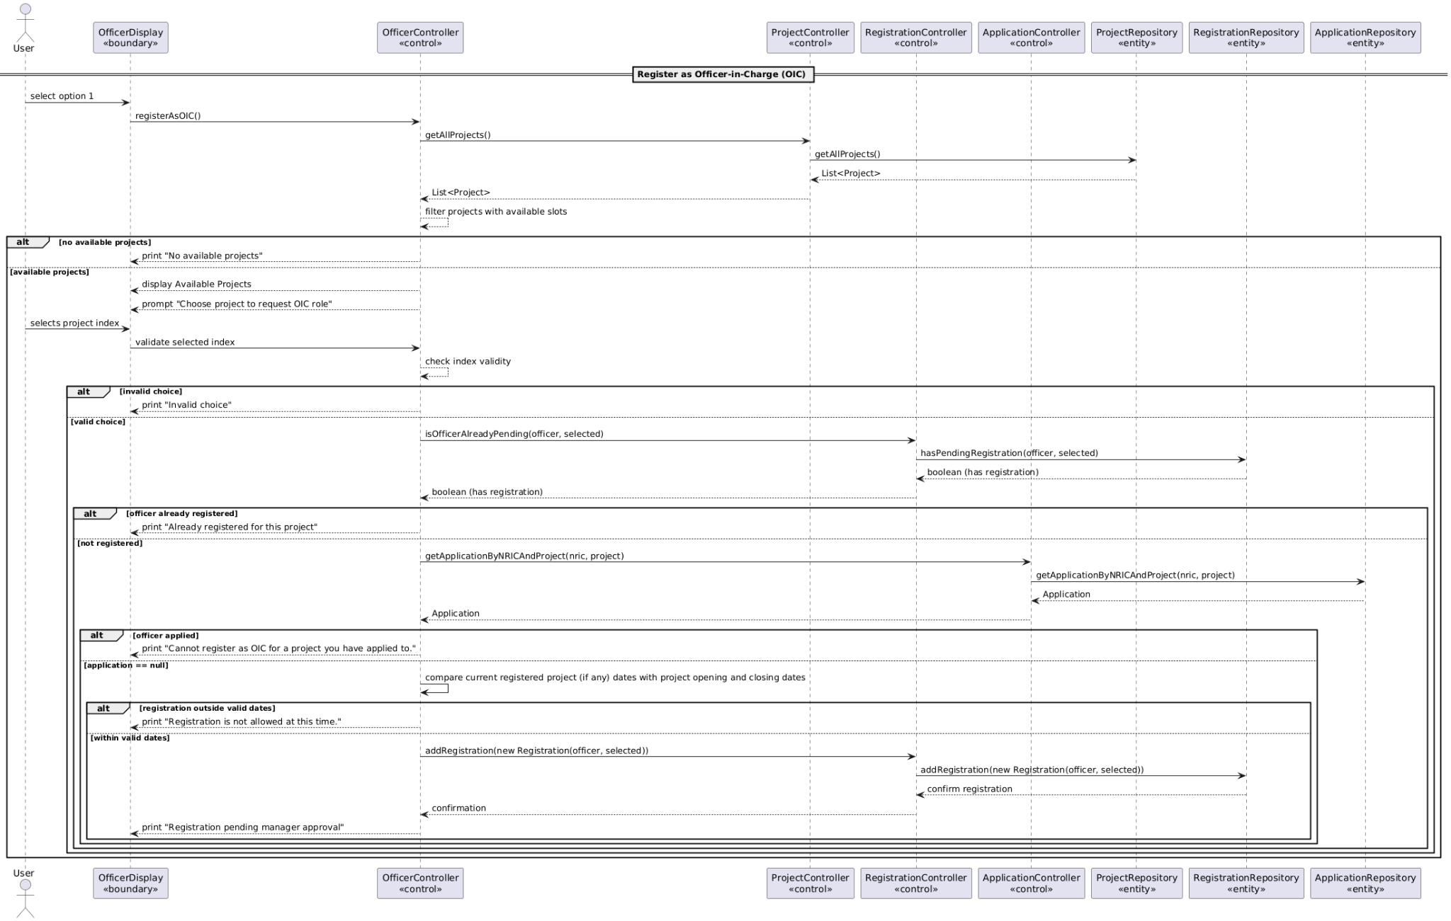

SEQUENCE DIAGRAM 5:

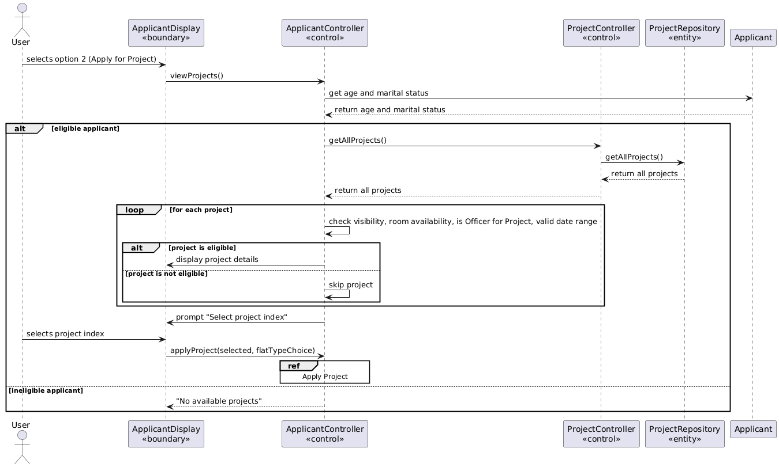

SEQUENCE DIAGRAM 6:

